**Title: A global box model of plastics cycling between land, ocean and atmosphere**

**Title: Global plastics cycling budget and dynamics**

Jeroen E. Sonke1*, Alkuin Koenig, Oskar Hagelskjaer, Henar Margenat, Sophia Hansson, Francois de Vleeschouwer, Olivier Magand, Aurelien Dommergue, Gael Le Roux, Jennie Thomas

1 Géosciences Environnement Toulouse, CNRS/IRD/Université Paul Sabatier Toulouse 3, France

*Corresponding author : [jeroen.sonke@get.omp.eu](mailto:jeroen.sonke@get.omp.eu)

Keywords: microplastics, mass fluxes, emission, deposition, river, deep ocean, beach, sediment, soil, waste, litter, debris, Anthropocene

**Abstract**

Since 1950 humans have introduced 8300 teragrams (Tg, 1012 grams) of plastic polymers into the Earth’s surface environment. The non-natural chemical properties of plastics, and their complex global cycle complicate risk assessment and policy making. Recent studies have improved our understanding of the global river budget for plastic transport to oceans, the sinking and beaching of marine plastics and the emission and deposition of atmospheric microplastics. Here we define a global plastics cycle and budget, and develop a box model of plastic cycling, including the fragmentation and transport of large and small microplastics (MP, sMP) within coupled terrestrial, oceanic and atmospheric reservoirs. We drive the model with historical plastics production data, and explore how macroplastics, MP and sMP propagate through the reservoirs from 1950 to 2015. We find that ‘missing plastics’ in the surface ocean reside most likely in the deep ocean (80 Tg), on beaches (0.5 Tg) and, as a result of marine emissions, in terrestrial soils (29Tg). A river plastics flux of 1.3 Tg y-1 is needed to explain the global plastics budget, and is larger than terrestrial sMP emission of 0.27 Tg y-1. Business as usual release of plastics will increase atmospheric and aquatic ecosystem exposure X-fold by 2050, while zero-release … Modelled dispersal potential is largest from the terrestrial discarded pool, which is where release, containment and remediation policy efforts would be most efficient.

**Introduction**

An emblematic feature of the Anthropocene is the widespread dispersal of plastic polymers across Earth’s surface since the 1950s (Carpenter Edward J. and Smith K. L., 1972). Of the 1.5 trillion barrels of oil (200,000 Tg) produced since the 1950s (Hughes and Rudolph, 2011) about 4% (8300 Tg) has been transformed into non-biodegradable polymer, and used in predominantly single-use packaging or short-lived (1-25y) technological applications (Geyer et al., 2017a). Plastics have been abundantly (60%) discarded into the anthroposphere, the part of the environment that has been made or modified by humans: urban, sub-urban, agricultural, industrial areas, including landfills (Geyer et al., 2017a; Lau Winnie W. Y. et al., 2020). The discarded pool of plastics has been slowly mobilized by wind, runoff, rivers and ocean currents to all remote corners of planet Earth, including the poles and the deep Ocean (Allen et al., 2019; Peeken et al., 2018; X. Peng et al., 2018). Being non-biodegradeable, large plastic debris tend to fragment to micro- and nano-sized particles, which due to their increased surface area can absorb, adsorb or release a range of secondary natural and man-made chemical compounds in the environment. Assessing the possible impact of plastics on ecosystem and human health, and mitigating this impact, requires a solid understanding of where and when discarded plastics end-up, and in what size range they evolve.

Over the past decades important efforts have been made to chart the abundance, size properties, and bulk polymer composition of plastics in the surface ocean, soils, rivers, wetlands, biota and atmosphere. A perceived mismatch between the amount of plastics in the surface ocean (0.3 Tg)(Eriksen et al., 2014) and the amount delivered by global rivers (4.8 – 12.7 Tg y-1)(Jambeck Jenna R. et al., 2015a) has fueled a ‘missing marine plastics’ paradox. Solutions to this issue have been proposed in the transfer of marine plastics to the deep ocean (Koelmans et al., 2017), to coastal environments, via beaching and sedimentation (Onink et al., 2021; Lebreton et al., 2019) , to sedimentation in the deep ocean, and to atmospheric emission of microplastics (Brahney et al., 2021). Recently, a revision of the river plastic flux to the ocean was made, based on alternative plastic size distribution assumptions (Weiss et al., 2021), yielding a 1000-fold lower global river flux of 0.0064 Tg y-1 (median, IQR 0.0036 to 0.018, n=6 regression models with R2≥0.66). Such a low river flux would imply a marine residence time of several years, and possibly removes the need for a missing marine plastics sink. In parallel to marine plastics, the atmosphere has been identified as a global vector of microplastics, in both urban (Dris et al., 2016; Cai et al., 2017) and remote environments (Allen et al., 2019; Brahney et al., 2020; Allen et al., 2021), including likely microplastic emission from land (Evangeliou et al., 2020; Brahney et al., 2021) and sea (Allen et al., 2020; Brahney et al., 2021).

In this study we expand on these recent refinements and exploration of plastics abundance and fluxes in various Earth surface environments to construct a global plastics budget, and box model of plastics cycling from 1950 to 2014. We subdivide macroplastics (P, >5mm), microplastics (MP, >0.3mm and <5mm) and small microplastics (sMP, <0.3mm). We estimate approximate dispersal of plastics to the anthroposphere of 92% (20% in use, 82% discarded), to the marine and coastal environment of 0.3%, and to pristine soils of 3%. We illustrate the important role of atmospheric transport in global plastics dispersal. We use the model to examine future global plastics management scenarios, indicating ocean clean-up to be the least effective, and remediation of the anthroposphere, including intense recycling, to be imperative.

**Plastics cycling box model**

In order to construct a global plastics mass and mass transfer budget, we use plastics observations from the literature and a box modeling approach (see methods for details). The model is a coupled 9-reservoir numerical box model that simulates how produced macroplastics, P, and microplastics, MP and sMP, propagate through the anthroposphere, oceans, atmosphere and soils upon discard. P fragment to MP, and MP fragment to sMP in the terrestrial and marine environment, and only sMP become airborne, emitted from and deposited to oceans and land. Terminal P, MP and SMP sinks are marine sediments, whereas soils and deep ocean act as long-term temporary reservoirs. The mass flux, Fab (Tg y-1) between two reservoirs a and b is Fab = kab × Ma, where Ma is the mass of plastics in reservoir *a* (Tg), and kab is a first-order mass transfer (rate) coefficient (y-1). In a first step, all kvalues are determined from recent, 2005-2020, observations and model estimates of plastic fluxes and reservoir sizes. The model is then run from 1950 to 2015, with only the k values and plastics production and waste generation as external forcing. In the following we discuss whether the simulated modern plastics distribution for 2015 corresponds to observations, which k values (and therefore fluxes) need to be adjusted, and what the model implications are for our understanding of plastic cycling. With the addition of atmospheric transport of plastics, the term ‘emission’ refers here exclusively to the suspension of terrestrial and marine plastics in air. ‘Release’ is used as the generic term for plastics discharge and mobilization to the anthroposphere and in-land aquatic and marine environments. Conversion of plastics number concentrations to mass concentrations is detailed in the SI. All uncertainties reported are 1σ, or interquartile range.

We start by detailing the ‘base case’ plastics cycling model, based on best known modern observations of reservoir sizes and fluxes between reservoirs (see Methods for details). We include plastics production (8300 Tg since 1950), waste generation and waste disposal from (Geyer et al., 2017a) who estimated 2600 Tg of plastics to be in use in 2015, 4900 Tg discarded (split into 4200 Tg of P, and 700 of primary MP following (Lau Winnie W. Y. et al., 2020)) and 800 Tg incinerated. In the base case we use a river plastics flux of 0.0064 Tg y-1 from (Weiss et al., 2021) containing equal fractions of P and MP, surface ocean mixed layer buoyant P and MP inventories of 0.23 and 0.04 Tg (Eriksen et al., 2014), and surface mixed layer sMP inventory of 0.003 Tg (Poulain et al., 2019). We make an order of magnitude estimate of beached MP of 0.5 Tg, based on the global surface of sandy beaches (2.63 105 km2; (Almar et al., 2021)), a median global beach sand MP abundance of 2450 MP km-2 , and median MP size of 2.0 mm (Shim et al., 2018). No observational estimate is available for beached macroplastics. Rate coefficients for P and MP beaching (the transfer from ocean to beach), kbeaching of 0.15 y-1 are approximated based on (Onink et al., 2021). Surface mixed layer to deep subsurface ocean sinking rates of P, MP, sMP lack observations; we estimate model sinking rate coefficients kP,sinking of 196 y-1 for MP and kP,sinking of 33 y-1 for sMP from the 100 m deep surface ocean mixed layer, based on the empirical results of a sinking tank study of mixed phytoplankton aggregates with microplastics (Long et al., 2015). We do not include the sinking of macroplastics, P, to subsurface waters due to lack of data; P are beached as described above, and fragmented in surface waters to MP at a rate koceP🡪MP of 0.03 y-1 (Lebreton et al., 2019). In the absence of fragmentation rates for MP to sMP in surface, subsurface waters, beach zone, and discarded pool, and for P to MP in subsurface water, beach zone and discarded pool we adopt, in the ‘base case’ the same rate koceMP🡪sMP of 0.03 y-1 for all these fragmentation sites.

The intermediate and deep ocean pool of MP and sMP, below the surface mixed layer, is of importance to complete the marine plastics budget and to quantify settling and sedimentation of plastics. Table 1 and Figure 2 summarize recent observations of subsurface marine plastics. We estimate a global deep Ocean sMP+MP inventory of 80 ± 48 Tg based on mean N-Pacific pelagic concentrations of 131 ± 44 µg m-3 (Peng et al., 2018; Eo et al., 2021), mean N and S-Atlantic concentrations of 91 ± 46 µg m-3 (Courtene-Jones et al., 2017; Pabortsava and Lampitt, 2020; Zhao et al., 2022), and extrapolated estimates for the Indian, Southern, and S-Pacific Oceans (Table 2).

Recent studies on atmospheric microplastics cycling show fragment and fiber size distributions to be in the sMP range <300 µm. While larger MP emission and deposition occurs, these tend to deposit more rapidly back to the same reservoir (e.g. marine emission followed by marine deposition) and are therefore ignored in the box model. Table 3 summarizes sMP observations in the boundary layer and free troposphere, yielding a total tropospheric sMP mass of 0.031 ± 0.027 Tg, which is 10x lower, though within uncertainty of a model estimate of 0.0036 Tg (Brahney et al., 2021). Our estimate of 0.031 Tg is very sensitive to the assumed median sMP size of 70 µm, which is where sMP models allocate most mass (Brahney et al., 2021). We adopt global sMP emissions from the same model study (Brahney et al., 2021): emissions from roads, 0.01 Tg y-1, agricultural dust, 0.07 Tg y-1, population dust, 0.02 Tg y-1, and oceans, 8.6 Tg y-1. We use sMP deposition observations over land (Klein and Fischer, 2019; Brahney et al., 2020; Allen et al., 2019) in combination with population density data for 2015 (World Bank, 2021) to estimate global sMP deposition over land of 1.2 Tg y-1 and an accumulated remote soil sMP pool of 29 Tg (see Methods). We assume that global sMP emissions (8.6 Tg y-1; (Brahney et al., 2021)) equal deposition, and estimate sMP deposition over oceans to be 7.6 Tg y-1 (total deposition of 8.6 Tg y-1 – 1.2 Tg y-1 deposition over land).

The box model base case is run from 1950 to 2015 and results, in terms of plastics reservoir sizes and fluxes for the year 2015, are shown in Figure S1 in comparison to the above mentioned observations. The base run reproduces observed amounts of in-use P, discarded P, MP, sMP and soil sMP to within 40%. The base run underestimates however the total plastics mass in the marine system (surface, deep ocean, sediments, beach) by a factor of 32, and the individual marine reservoirs by factors of 0.5 (surface ocean sMP) to 1900 (surface ocean MP). Whereas the total marine plastics mass, dominated by the uncertain deep ocean budget (69 out of 73 Tg), is not well constrained, the surface ocean P and MP masses are better known, based on observations (Eriksen et al., 2014). Surface ocean P and MP in the box model depends strongly on river inputs, and MP also on settlement below the surface mixed layer and on MP sedimentation to shelf sediments. To bring model surface ocean MP to within a factor 10 of observations, both MP sinking and sedimentation rate constants, which are based on experimental sinking velocities, would have to be over-estimated by a factor of 500. We consider this unlikely, especially for sedimentation over the continental shelf. In addition it would not fix the x20 underestimated surface ocean P mass. It appears more likely that the base case river P and MP flux of 0.006 Tg y-1 by (Weiss et al., 2021)(down from earlier estimates of 5 to 13 Tg y-1)(Jambeck Jenna R. et al., 2015b) is now underestimated. Increasing river P and MP flux by a factor of 200, to 1.3 Tg y-1) leads to satisfactory (within a factor 10x) model reproduction of all marine P, MP and sMP reservoirs, without any further adjustment of beaching, sedimentation, fragmentation or emission rate coefficients (Figure S2).

The single adjustment of river plastics transport does not affect discarded and soil plastic pools on land. Any further optimization of a single critical marine parameter, such as the MP fragmentation, sinking and beaching rates, requires adjustment of other rates which is not constrained by observations at this point. The large model discarded sMP pool size of 565 Tg is not constrained by observations, and leads to a large model sMP emission of 3.6 Tg y-1 compared to a published emission estimate of 0.09 Tg y-1 (Brahney et al., 2021). Therefore, a 2nd adjustment we do consider justified, is to lower the ocean-based fragmentation rate of P and MP in the discarded pool 5x from 0.03 to 0.006 y-1. Doing so decreases the model discarded sMP pool to 75 Tg, and the discarded sMP emission to 0.48 Tg y-1, without strong perturbation of other reservoirs and fluxes. We argue it is reasonable to assume a slower fragmentation rate in the terrestrial anthroposphere due to the absence of physical abrasion typical of the marine environment, especially in the surf zone.

Figure 2 presents our best estimate of the global plastics cycle for the year 2015, based on observed inventories and fluxes (black), modeled inventories and fluxes (red), and the single adjusted parameter, a river P and MP flux of 1.3 Tg y-1 to the ocean. Key properties of the global plastics cycle are 1. The large mass of discarded MP (869 Tg) and sMP (75 Tg) in the terrestrial environment, which are potentially mobilizable to wetlands and oceans, 2. The similar order of magnitude of river plastics flux (1.3 Tg y-1) and primary terrestrial atmospheric sMP emission flux (0.5 Tg y-1), 3. The importance of marine sMP emissions on further distributing plastics to remote natural soils and remote ocean waters, 4. The potentially large subsurface oceanic MP and sMP reservoir (80 Tg).

We use the box model to simulate three plastics management scenarios: 1. A business as usual (BAU) scenario from Geyer et al., reaching 26,000 Tg of produced plastics in 2050, 2. The systems change scenario (SCS) from Lau et al. representing …, and 3. An unrealistic full stop on non-biodegradable plastics use in 2025, which serves to illustrate at what timescales P, MP and sMP propagate through Earth surface reservoirs, and where waste remediation efforts may have most effects.

….. Figure X illustrates P, MP and sMP dispersal under the BAU scenario….

….. Figure Y illustrates P, MP and sMP dispersal under the SCS scenario….

Figure 3 illustrates P, MP and sMP dispersal after a full stop on plastics production in 2025. The discarded terrestrial P pool decreases rapidly, by 90% in 2100, due to fragmentation to MP, which in turn decrease by 70% in 2100 due to further fragmentation to sMP. MP and sMP transport to oceans and air leads to rapid increases of MP and sMP in the marine pools and of sMP in the remote soil pool. This scenario illustrates that even if we would entirely replace plastics by alternative materials, the legacy of historical plastics mismanagement could result in prolonged plastics dispersal over centuries (MP) or millenia (sMP).

Etc…

**Methods**

Definitions of plastics size categories are continuously debated; here we use operational definitions of macroplastics (P, >5mm), microplastics (MP, >0.3mm and <5mm) and small microplastics (sMP, <0.3mm). The 0.3mm distinction is based on the frequently used plankton net mesh size of 0.335 mm. For inclusion of atmospheric cycling of sMP, the 0.3mm cut-off is also a reasonable starting point, with nearly all remote airborn sMP particles, films and 50% of fibers falling in the 1-300 µm range (Brahney et al., 2020; Allen et al., 2019). All P, MP, sMP reservoir sizes (i.e. inventory) and fluxes are expressed in teragrams (Tg = 1012 grams) and Tg y-1.

We use global plastics production, 8300 Tg (teragrams or millions of metric tons), and disposal (discarded, recycled or incinerated) from (Geyer et al., 2017b). Produced plastics enter the ‘in-use’ reservoir, where they are mostly discarded within a single year due to the dominant use of single-use packaging. In 2015, 55% of non-fiber plastics are still discarded within a year, 35% incinerated and 25% recycled (Geyer et al., 2017b). We assume fiber plastics to undergo similar relative discarding and incineration fates, but not recycling, leading to a ‘discarded P+MP’ reservoir of 4900 Tg, an incinerated pool of 800 Tg (atmospheric CO2) and an in-use pool of 2600 Tg in 2015. Lau et al. estimated the proportion of plastic pollution that enters aquatic and terrestrial environments as primary MP to be 28% in 2016 (Lau Winnie W. Y. et al., 2020). We apply this primary MP fraction to estimate transfer from the in-use to discarded reservoir for the period 2050-2015. The following mass balance equations are defined for in-use and discarded pools:

$\frac{d{(P}_{use})}{dt}=P_{prod}-f_{disc}×P_{waste}-f_{inc}×P_{waste}-f_{rec}×P_{waste}$ (Eq.1)

Where Puse is the mass of total plastic (P + MP) in use, Pprod the mass of total plastics produced (Tg y-1), Pwaste the mass of total plastic waste, and fdisc, finc and frec are the fractions of Puse that are discarded, incinerated and recycled.

$\frac{d{(P}_{disc})}{dt}=f_{disc}×P_{waste}×(1-f_{MP})-k_{P-river}×P_{disc}$ (Eq.2)

Where Pdisc is the mass of P discarded, fMP is the fraction of discarded P that are primary microplastics (pellets, synthetic textiles, personal care products), kP-river is the transfer coefficient for P to the ocean, via river runoff.

$\frac{d(MP_{disc})}{dt}=f_{disc}×P_{waste}×f_{MP}-k_{MP-river}×{MP}_{disc}-k_{MP→sMP}×{MP}_{disc}$ (Eq.3)

Where MPdisc is the mass of MP discarded, kMP-river is the transfer coefficient for MP to the ocean, via river runoff, and kMP🡪sMP is the transfer coefficient for MP degradation to sMP within the terrestrial ‘discarded’ pool.

$\frac{d(sMP_{disc})}{dt}=k_{MP→sMP}×{MP}_{disc}-k_{sMP-river}×{sMP}_{disc}-k_{disc-atm}×{sMP}_{disc}$ (Eq.4)

Where sMPdisc is the mass of sMP discarded, ksMP-river is the transfer coefficient for sMP to the ocean, via river runoff, and ksMP-atm is the transfer coefficient for sMP emission to the atmosphere from the terrestrial ‘discarded’ pool, including tire wear particles (TWP).

Transfer coefficients kP-river, kMP-river, ksMP-river and ksMP-atm are estimated from 2015 plastic fluxes and inventories, e.g. kP-river=Pdisc/FP-river where F stands for flux (Table S1). High estimates of river plastic flux in the range 4.8 – 12.7 Tg y-1 ((Jambeck Jenna R. et al., 2015b; Lebreton et al., 2017)) have been at the center of a ‘missing oceanic plastics’ paradox. A 1000-fold lower river plastic flux to the Ocean of 6.4 Gg y-1 (median, IQR 3.6 to 17.8, n=6 regression models with R2≥0.66) was recently presented by Weiss et al (Weiss et al., 2021). The authors indicated that approximately 50% of the river flux are macroplastics and 50% MP, which we adopt here.

*The global ocean.* Two previous box models have examined the plastics budget of the marine environment (Koelmans; Lebreton). In addition, a number of Lagrangian oceanic or atmospheric transport models have provided insight in marine plastics dispersal and surface ocean plastics mass balance (van Sebille; Onink; Evangeliou; Brahney 2021 PNAs). Koelmans et al., at a time of elevated river plastics estimates, used a plastics mass budget for the surface ocean to fit a marine P to MP fragmentation rate, and a MP sedimentation rate, under the assumption of 100% buoyant macroplastics (no settling to deep waters). To accommodate the high river plastic inputs, rapid plastic fragmentation to MP (>90% per year), and rapid MP settling rates were fitted, and suggested a short plastics and MP residence time for the surface ocean (<3 yrs). Subsequent modeling work has investigated P and MP beaching, resuspension in coastal waters (Lebreton 2019; Onink 2021), marine sMP emissions (Brahney 2021), and P sedimentation due to loss of buyuancy (Lebreton19). Lebreton et al., in their marine box model study (Lebreton et al., 2019), argued that observations of old plastics in the surface ocean disagree with rapid fragmentation and settling and fitted a plastics to MP degradation rate of 3% per year, which we adopt here for the surface mixed layer (kP,deg = 0.03 y-1). Lebreton et al. (2019) fitted important beaching of coastal plastics (97% per year). In the absence of a robust estimate for global beached macroplastics (Browne et al., 2015), Onink et al. recently analyzed model beaching and resuspension scenarios finding at least 77% of net beaching for positively buoyant plastic debris over 5 years, which we adopt here and express as kP,beaching = 0.15 y-1. Surface ocean P, MP, and sMP equations are:

$\frac{d(P_{oce})}{dt}=k_{P-river}×P_{disc}-k_{Poce-beach}×P_{oce}-k_{Poce-sed}×P_{oce}$ (Eq.5)

$\frac{d({MP}_{oce})}{dt}=k_{MP-river}×{MP}_{disc}-k_{MPoce-beach}×{MP}_{oce}-k_{MPoce-sed}×{MP}_{oce}$ (Eq.6)

$\frac{d({sMP}_{oce})}{dt}=k_{sMP-river}×{sMP}_{disc}+k_{atm-oce}×{sMP}_{atm}+k_{soil-oce}×{sMP}_{soil}-k_{oce-atm}×{sMP}_{oce}-k_{sMPoce-sed}×{sMP}_{oce}$ (Eq.7)

Subsurface Ocean equations are:

$\frac{d({MP}_{deep-oce})}{dt}=k_{MP-sink}×{MP}_{surf-oce}×f_{pelagic}-k_{MP→sMP}×{MP}_{deep-oce}$ (Eq.8)

$\frac{d({sMP}_{deep-oce})}{dt}=k_{sMP-sink}×{sMP}_{surf-oce}×f_{pelagic}+k_{MP→sMP}×{MP}_{deep-oce}$ (Eq.9)

$\frac{d(P_{beach})}{dt}=k_{P-beach}×P_{surf-oce}$ (Eq.10)

$\frac{d({MP}_{beach})}{dt}=k_{MP-beach}×{MP}_{surf-oce}$ (Eq.11)

$\frac{d({MP}_{sed})}{dt}=k_{MP-sed}×{MP}_{surf-oce}×f_{shelf}$ (Eq.12)

$\frac{d({sMP}_{sed})}{dt}=k_{sMP-sed}×{sMP}_{surf-oce}×f_{shelf}$ (Eq.13)

*The global atmosphere.* Brahney et al. estimated the global atmosphere to contain 0.0036 Tg of sMP (Brahney et al., 2021, 2020). They also estimated global emissions from roads, 0.096 Tg y-1, agricultural dust, 0.069 Tg y-1, population dust, 0.018 Tg y-1, and oceans, 8.6 Tg y-1, which we adopt here. Atmospheric sMP deposition to remote areas has been investigated by Allen et al. in France, finding a median sMP deposition of 0.011 Tg km-2 y-1, and by Brahney et al. who observed a median of 0.0012 Mg km-2 y-1 in the western USA (Brahney et al., 2020). Similar sampling and analysis techniques were used, and similar sMP particle and fiber size distributions found, suggesting that the 9x difference reflects the difference in population density of both areas, 100 inhabitants per km2 in SW Europe vs. 16 per km2 in the western USA. In (sub-)urban environments in Hamburg (Germany, 240 inhabitants per km2) median sMP deposition of 0.017 Tg km-2 y-1 was observed (Klein and Fischer, 2019). Precursor studies on atmospheric plastics observed mostly the larger MP fiber fraction (0.3 to 5mm) with for example 0.014 Tg MP km-2 y-1 in Dongguan (China) (Cai et al., 2017), but only 0.002 Tg km-2 y-1 in Paris (France) (Dris et al., 2016). For simplicity we do not include larger MP emission to the atmosphere in the box model, since the short residence time of MP likely leads to immediate deposition back to the broad terrestrial discarded MP reservoir. We regress sMP deposition over land, from the three detailed recent studies mentioned above, as a function of population density (Figure SX). We then extrapolate the observed relationship globally using population density and surface area data per country for the year 2015 (World Bank, 2021), capping sMP deposition at 0.017 Tg km-2 y-1 based on the Hamburg observations. Doing so leads to a global sMP deposition estimate over land of 1.15 Tg y-1. sMP deposition over Oceans is unconstrained by observations. We assume that global sMP emissions (8.6 Tg y-1; (Brahney et al., 2021)) equal deposition, and estimate sMP deposition over oceans to be 7.64 Tg y-1 (total deposition of 8.6 Tg y-1 – 1.15 Tg y-1 deposition over land).

The mass inventory, emission and deposition flux estimates for 2015 serve to approximate the mass transfer coefficients associated with emission and deposition in the following mass balance equation:

$\frac{d(sMP_{atm})}{dt}=k_{disc-atm}×{sMP}_{disc}+k_{oce-atm}×{sMP}_{oce}-k_{atm-soil}×{sMP}_{atm}-k_{atm-oce}×{sMP}_{atm}$ (Eq.14)

*Remote soils.* In the box model agricultural and urban soils are included in the discarded plastics pool. We use a separate box for remote soils, outside of the anthroposphere, that is solely supplied by atmospheric sMP. Insufficient data is available for plastics in remote soils. We therefore estimate this pool by making use of the quasi-linear increase in global plastics production, discard and dispersal fluxes: global sMP deposition of 1.15 Tg y-1 in 2015 suggests a mean sMP deposition flux that is about half, 0.58 Tg y-1 since 1965, which multiplied by a land surface area of 1.49 108 km2 amounts to 29 Tg of remote soil sMP. The remote soil mass balance is:

$\frac{d(sMP_{soil})}{dt}=k_{atm-soil}×{sMP}_{atm}-k_{soil-atm}×{sMP}_{soil}-k_{sMP→river-oce}×{sMP}_{soil}$ (Eq. 14)

*Budget and model uncertainty.* The model assumes no temporal evolution of the mass transfer coefficients, k, implying that fragmentation, sedimentation, emission and release dynamics are considered time-invariant. While we argue that to first order these processes have remained similar through time, we acknowledge that reality is more complex. As more observational and mechanistic studies become available over the next decade, more appropriate parameterizations for plastics cycling can be tested, including the fragmentation of sMP to nanoplastics.

**Acknowledgements**

We acknowledge financial support via the ANR-20-CE34-0014 ATMO-PLASTIC project, the Plasticopyr project within the Interreg V-A Spain-France-Andorra programme, a CNRS 80prime PhD scholarship, and a MSCA ITN GMOS-Train PhD scholarship via grant agreement No 860497.

**Author contributions**

JES designed the study. JES and AK developed the model. All authors reviewed literature data, and contributed to model data interpretation and writing.

**References**

Allen, S., Allen, D., Phoenix, V. R., Le Roux, G., Durántez Jiménez, P., Simonneau, A., Binet, S., and Galop, D.: Atmospheric transport and deposition of microplastics in a remote mountain catchment, Nat. Geosci., 12, 339–344, https://doi.org/10.1038/s41561-019-0335-5, 2019.

Allen, S., Allen, D., Moss, K., Le Roux, G., Phoenix, V. R., and Sonke, J. E.: Examination of the ocean as a source for atmospheric microplastics, Plos One, https://doi.org/doi: 10.1371/journal.pone.0232746, 2020.

Allen, S., Allen, D., Baladima, F., Thomas, J., Le Roux, G., Phoenix, V. R., and Sonke, J. E.: Evidence of free tropospheric and long-range transport of microplastic at Pic du Midi Observatory, Nat. Commun., https://doi.org/in press, 2021.

Almar, R., Ranasinghe, R., Bergsma, E. W. J., Diaz, H., Melet, A., Papa, F., Vousdoukas, M., Athanasiou, P., Dada, O., Almeida, L. P., and Kestenare, E.: A global analysis of extreme coastal water levels with implications for potential coastal overtopping, Nat. Commun., 12, 3775, https://doi.org/10.1038/s41467-021-24008-9, 2021.

Brahney, J., Hallerud, M., Heim, E., Hahnenberger, M., and Sukumaran, S.: Plastic rain in protected areas of the United States, Science, 368, 1257–1260, https://doi.org/10.1126/science.aaz5819, 2020.

Brahney, J., Mahowald, N., Prank, M., Cornwell, G., Klimont, Z., Matsui, H., and Prather, K. A.: Constraining the atmospheric limb of the plastic cycle, Proc. Natl. Acad. Sci., 118, https://doi.org/10.1073/pnas.2020719118, 2021.

Browne, M. A., Chapman, M. G., Thompson, R. C., Amaral Zettler, L. A., Jambeck, J., and Mallos, N. J.: Spatial and Temporal Patterns of Stranded Intertidal Marine Debris: Is There a Picture of Global Change?, Environ. Sci. Technol., 49, 7082–7094, https://doi.org/10.1021/es5060572, 2015.

Cai, L., Wang, J., Peng, J., Tan, Z., Zhan, Z., Tan, X., and Chen, Q.: Characteristic of microplastics in the atmospheric fallout from Dongguan city, China: preliminary research and first evidence, Environ. Sci. Pollut. Res., 24, 24928–24935, https://doi.org/10.1007/s11356-017-0116-x, 2017.

Carpenter Edward J. and Smith K. L.: Plastics on the Sargasso Sea Surface, Science, 175, 1240–1241, https://doi.org/10.1126/science.175.4027.1240, 1972.

Courtene-Jones, W., Quinn, B., Gary, S. F., Mogg, A. O. M., and Narayanaswamy, B. E.: Microplastic pollution identified in deep-sea water and ingested by benthic invertebrates in the Rockall Trough, North Atlantic Ocean, Environ. Pollut., 231, 271–280, https://doi.org/10.1016/j.envpol.2017.08.026, 2017.

Dris, R., Gasperi, J., Saad, M., Mirande, C., and Tassin, B.: Synthetic fibers in atmospheric fallout: A source of microplastics in the environment?, Mar. Pollut. Bull., 104, 290–293, https://doi.org/10.1016/j.marpolbul.2016.01.006, 2016.

Eo, S., Hong, S. H., Song, Y. K., Han, G. M., Seo, S., and Shim, W. J.: Prevalence of small high-density microplastics in the continental shelf and deep sea waters of East Asia, Water Res., 200, 117238, https://doi.org/10.1016/j.watres.2021.117238, 2021.

Eriksen, M., Lebreton, L. C. M., Carson, H. S., Thiel, M., Moore, C. J., Borerro, J. C., Galgani, F., Ryan, P. G., and Reisser, J.: Plastic Pollution in the World’s Oceans: More than 5 Trillion Plastic Pieces Weighing over 250,000 Tons Afloat at Sea, PLOS ONE, 9, 1–15, https://doi.org/10.1371/journal.pone.0111913, 2014.

Evangeliou, N., Grythe, H., Klimont, Z., Heyes, C., Eckhardt, S., Lopez-Aparicio, S., and Stohl, A.: Atmospheric Transport, a Major Pathway of Microplastics to Remote Regions., Preprints, 2020030385, https://doi.org/doi: 10.20944/preprints202003.0385.v1, 2020.

Geyer, Jambeck Jenna R., and Law Kara Lavender: Production, use, and fate of all plastics ever made, Sci. Adv., 3, e1700782, https://doi.org/10.1126/sciadv.1700782, 2017a.

Geyer, R., Jambeck, J. R., and Law, K. L.: Production, use, and fate of all plastics ever made, Sci. Adv., 3, https://doi.org/10.1126/sciadv.1700782, 2017b.

Hughes, L. and Rudolph, J.: Future world oil production: growth, plateau, or peak?, Energy Syst., 3, 225–234, https://doi.org/10.1016/j.cosust.2011.05.001, 2011.

Jambeck Jenna R., Geyer Roland, Wilcox Chris, Siegler Theodore R., Perryman Miriam, Andrady Anthony, Narayan Ramani, and Law Kara Lavender: Plastic waste inputs from land into the ocean, Science, 347, 768–771, https://doi.org/10.1126/science.1260352, 2015a.

Jambeck Jenna R., Geyer Roland, Wilcox Chris, Siegler Theodore R., Perryman Miriam, Andrady Anthony, Narayan Ramani, and Law Kara Lavender: Plastic waste inputs from land into the ocean, Science, 347, 768–771, https://doi.org/10.1126/science.1260352, 2015b.

Kanhai, L. D. K., Gårdfeldt, K., Lyashevska, O., Hassellöv, M., Thompson, R. C., and O’Connor, I.: Microplastics in sub-surface waters of the Arctic Central Basin, Mar. Pollut. Bull., 130, 8–18, https://doi.org/10.1016/j.marpolbul.2018.03.011, 2018.

Klein, M. and Fischer, E. K.: Microplastic abundance in atmospheric deposition within the Metropolitan area of Hamburg, Germany, Sci. Total Environ., 685, 96–103, https://doi.org/10.1016/j.scitotenv.2019.05.405, 2019.

Koelmans, A. A., Kooi, M., Law, K. L., and van Sebille, E.: All is not lost: deriving a top-down mass budget of plastic at sea, Environ. Res. Lett., 12, 114028, https://doi.org/10.1088/1748-9326/aa9500, 2017.

Lau Winnie W. Y., Shiran Yonathan, Bailey Richard M., Cook Ed, Stuchtey Martin R., Koskella Julia, Velis Costas A., Godfrey Linda, Boucher Julien, Murphy Margaret B., Thompson Richard C., Jankowska Emilia, Castillo Castillo Arturo, Pilditch Toby D., Dixon Ben, Koerselman Laura, Kosior Edward, Favoino Enzo, Gutberlet Jutta, Baulch Sarah, Atreya Meera E., Fischer David, He Kevin K., Petit Milan M., Sumaila U. Rashid, Neil Emily, Bernhofen Mark V., Lawrence Keith, and Palardy James E.: Evaluating scenarios toward zero plastic pollution, Science, 369, 1455–1461, https://doi.org/10.1126/science.aba9475, 2020.

Lebreton, L., Egger, M., and Slat, B.: A global mass budget for positively buoyant macroplastic debris in the ocean, Sci. Rep., 9, 12922, https://doi.org/10.1038/s41598-019-49413-5, 2019.

Lebreton, L. C. M., Van der Zwet, J., Damsteeg, J.-W., Slat, B., Andrady, A., and Reisser, J.: River plastic emissions to the world’s oceans, Nat. Commun., 8, https://doi.org/10.1038/ncomms15611, 2017.

Long, M., Moriceau, B., Gallinari, M., Lambert, C., Huvet, A., Raffray, J., and Soudant, P.: Interactions between microplastics and phytoplankton aggregates: Impact on their respective fates, Part. Aquat. Environ. Invis. Exopolymers Sink. Aggreg., 175, 39–46, https://doi.org/10.1016/j.marchem.2015.04.003, 2015.

Onink, V., Jongedijk, C. E., Hoffman, M. J., van Sebille, E., and Laufkötter, C.: Global simulations of marine plastic transport show plastic trapping in coastal zones, Environ. Res. Lett., 16, 064053, https://doi.org/10.1088/1748-9326/abecbd, 2021.

Pabortsava, K. and Lampitt, R. S.: High concentrations of plastic hidden beneath the surface of the Atlantic Ocean, Nat. Commun., 11, 4073, https://doi.org/10.1038/s41467-020-17932-9, 2020.

Peeken, I., Primpke, S., Beyer, B., Guetermann, J., Katlein, C., Krumpen, T., Bergmann, M., Hehemann, L., and Gerdts, G.: Arctic sea ice is an important temporal sink and means of transport for microplastic, Nat. Commun., 9, https://doi.org/10.1038/s41467-018-03825-5, 2018.

Peng, X., Chen, M., Chen, S., Dasgupta, S., Xu, H., Ta, K., Du, M., Li, J., Guo, Z., and Bai, S.: Microplastics contaminate the deepest part of the world’s ocean, Geochem. Perspect. Lett., 9, 1–5, https://doi.org/10.7185/geochemlet.1829, 2018.

Poulain, M., Mercier, M. J., Brach, L., Martignac, M., Routaboul, C., Perez, E., Desjean, M. C., and ter Halle, A.: Small Microplastics As a Main Contributor to Plastic Mass Balance in the North Atlantic Subtropical Gyre, Environ. Sci. Technol., 53, 1157–1164, https://doi.org/10.1021/acs.est.8b05458, 2019.

Ross, P. S., Chastain, S., Vassilenko, E., Etemadifar, A., Zimmermann, S., Quesnel, S.-A., Eert, J., Solomon, E., Patankar, S., Posacka, A. M., and Williams, B.: Pervasive distribution of polyester fibres in the Arctic Ocean is driven by Atlantic inputs, Nat. Commun., 12, 106, https://doi.org/10.1038/s41467-020-20347-1, 2021.

Shim, W. J., Hong, S. H., and Eo, S.: Chapter 1 - Marine Microplastics: Abundance, Distribution, and Composition, in: Microplastic Contamination in Aquatic Environments, edited by: Zeng, E. Y., Elsevier, 1–26, https://doi.org/10.1016/B978-0-12-813747-5.00001-1, 2018.

Tekman, M. B., Wekerle, C., Lorenz, C., Primpke, S., Hasemann, C., Gerdts, G., and Bergmann, M.: Tying up Loose Ends of Microplastic Pollution in the Arctic: Distribution from the Sea Surface through the Water Column to Deep-Sea Sediments at the HAUSGARTEN Observatory, Environ. Sci. Technol., 54, 4079–4090, https://doi.org/10.1021/acs.est.9b06981, 2020.

Watkins, L., Sullivan, P. J., and Walter, M. T.: What You Net Depends on if You Grab: A Meta-analysis of Sampling Method’s Impact on Measured Aquatic Microplastic Concentration, Environ. Sci. Technol., https://doi.org/10.1021/acs.est.1c03019, 2021.

Weiss, L., Ludwig, W., Heussner, S., Canals, M., Ghiglione, J.-F., Estournel, C., Constant, M., and Kerhervé, P.: The missing ocean plastic sink: Gone with the rivers, Science, 373, 107–111, https://doi.org/10.1126/science.abe0290, 2021.

World Bank: Population density, https://www.worldbank.org/en/home, 2021.

X. Peng, M. Chen, S. Chen, S. Dasgupta, H. Xu, K. Ta, M. Du, J. Li, Z. Guo, and S. Bai: Microplastics contaminate the deepest part of the world’s ocean, Geochem. Perspect. Lett., 9, 1–5, https://doi.org/10.7185/geochemlet.1829, 2018.

Zhao, S., Zettler, E. R., Bos, R. P., Lin, P., Amaral-Zettler, L. A., and Mincer, T. J.: Large quantities of small microplastics permeate the surface ocean to abyssal depths in the South Atlantic Gyre, Glob. Change Biol., n/a, https://doi.org/10.1111/gcb.16089, 2022.

**Tables**

Table 1. Subsurface ocean microplastics observations. Microplastics include fragments and fibers in the 0.3 – 5 mm (MP) and <0.3 mm (sMP) range. Reported data in # m-3 were converted to mass concentrations, taking into account the full particle/fiber size distribution (see Methods).

|  |  |  |  |  |
| --- | --- | --- | --- | --- |
| **Ocean basin** | **Location** | **depth** | **MP+sMP** | **Reference** |
|  |  | m | µg m-3 |  |
| N-Pacific | Korean East Sea | 206 | 125 | (Eo et al., 2021) |
| N-Pacific | Korean East Sea | 2100 | 177 | (Eo et al., 2021) |
| N-Pacific | Marian Trench | 2673 | 90 | (Peng et al., 2018) |
| **mean** |  |  | **131** |  |
| 1σ |  |  | 44 |  |
| N- and S-Atlantic | -53o S to 47o N | 160 | 134 | (Pabortsava and Lampitt, 2020) |
| N-Atlantic | Rockall Trough | 2200 | 97 | (Courtene-Jones et al., 2017) |
| S-Atlantic | Gyre |  | 43 | (Eo et al., 2021) |
| **mean** |  |  | **91** |  |
| 1σ |  |  | 46 |  |
| Arctic Ocean | Central basin | 5 to 1000 | 6 | (Ross et al., 2021) |
| Arctic Ocean | Central basin | 1769 | 66 | (Kanhai et al., 2018) |
| Arctic Ocean | Fram Strait | 300 to 5570 | 0.2 | (Tekman et al., 2020) |
| **mean** |  |  | **24** |  |
| 1 σ |  |  | 36 |  |

Table 2. Global subsurface ocean microplastics budget. Atlantic, N-Pacific and Arctic Ocean data from Table 1. Microplastics include fragments and fibers in the 0.3 – 5 mm (MP) and <0.3 mm (sMP) range. Data for the S-Pacific and Southern Ocean are extrapolated based on surface Ocean data from (Shim et al., 2018) with uncertainties set to 10x. No data exists for the Indian Ocean, where concentrations were assumed equal to the S-Atlantic observations by (Eo et al., 2021)(Table 1). Subsurface oceanic budgets in Tg include do not include the mixed layer (upper 0.1km).

|  |  |  |  |  |  |
| --- | --- | --- | --- | --- | --- |
| **Ocean basin** | **Area** | **Volume** | **MP+sMP** | **MP+sMP** | **1σ** |
|  | km2 | km3 | µg m-3 | Tg | Tg |
| Arctic Ocean | 15558000 | 18750000 | 24 | 0.4 | 0.6 |
| North Atlantic | 41490000 | 146000000 | 91 | 13.0 | 3.0 |
| South Atlantic | 40270000 | 160000000 | 91 | 14.3 | 3.3 |
| Indian Ocean | 70560000 | 264000000 | 43 | 11.0 | 11.0 |
| North Pacific | 77010000 | 331000000 | 131 | 42.2 | 14.1 |
| South Pacific | 84750000 | 329000000 | 4 | 1.2 | 12.0 |
| Southern Ocean | 21960000 | 71800000 | 4 | 0.3 | 3.0 |
| **Total** |  |  |  | **82** | **47** |

Table 3. Atmospheric small microplastics (sMP) budget. BL, boundary layer; FT, free troposphere. Mean ± 1σ sMP concentrations in the BL (144 ± 124 ng m-3 for outdoors locations) and FT (0.3 ± 0.2 ng m-3) are from (Allen et al., 2021), assuming a mean sMP size of 70 μm for sMP in the BL, based on (Brahney et al., 2021).

|  |  |  |  |  |  |
| --- | --- | --- | --- | --- | --- |
|  | **BL height** | **FT height** | **Area** | **BL sMP** | **FT sMP** |
|  | km | km | km2 | Tg | Tg |
| ocean | 0.25 | 13 | 3.62 108 | 0.013 | 0.0014 |
| land | 0.75 | 13 | 1.48 108 | 0.016 | 0.0005 |
| Total |  |  |  | 0.031 | |

Table 4. Comparison of observed and modeled plastics mass and fluxes for the year 2015. Plastics are divided in macroplastics, P (>5 mm), large microplastics, MP (0.3 – 5mm), and small mircoplastics, sMP (<0.3 mm). M, mass; F, flux; obs/mod, the ratio of observed to modeled mass or flux.

|  |  |  |  |
| --- | --- | --- | --- |
| **Reservoir mass (M) or flux (F)** | **observation** | **model** | **obs/mod** |
| M_produced | 8300 | 8365 | 99% |
| M_P_in-use | 2600 | 3205 | 81% |
| M_P_discard | 4214 | 3417 | 123% |
| M_MP_discard | 686 | 869 | 79% |
| M_sMP_discard |  | 75 |  |
| M_P_Surface Ocean | 0.23 | 2.27 | 10% |
| M_MP_Surface Ocean | 0.036 | 0.0044 | 800% |
| M_sMP_Surface Ocean | 0.0028 | 0.0012 | 234% |
| M_MP_Deep Oceean | 82 | 9.0 | 906% |
| M_sMP_Deep Oceean |  | 3.9 |  |
| M_sMP_atmosphere | 0.0307 | 0.015 | 210% |
| M_sMP_remote soil | 29 | 6 | 455% |
| M_P_beach |  | 3.9 |  |
| M_MP_beach | 0.53 | 1.51 | 35% |
| M_MP_shelf sediment |  | 0.00 |  |
| M_sMP_shelf sediment | 3.5 | 1.09 | 318% |
| M_P Incinerated |  | 0.04 |  |
| M_P Recycled | 800 | 772 | 104% |
|  |  |  |  |
| F Pin-use to MPdiscard | 42 | 41 | 103% |
| F Pin-use to Pdiscard | 118 | 122 | 97% |
| F Pin-use incinerated | 74 | 74 | 100% |
| F Pin-use recycled | 56 | 57 | 100% |
| F_Pdiscard to MPdiscard |  | 21 |  |
| F_MPdiscard to sMPdiscard |  | 5 |  |
| F_P river |  | 0.51 |  |
| F_MP river |  | 0.13 |  |
| F_sMP river (from sMPdiscard) |  | 0.07 |  |
| F_sMP river (from remote soil) |  | 0.006 |  |
| F_river total | 0.006 - 14 | 0.72 | adjusted |
| F_Surface Ocean P to MP |  | 0.068 |  |
| F_Surface Ocean MP to sMP |  | 0.00013 |  |
| F_sMP_Ocean to atmosphere | 8.6 | 4 | 234% |
| F_sMP_Atmosphere to ocean | 7.6 | 4 | 210% |
| F_P beaching |  | 0.35 |  |
| F_MP beaching |  | 0.00068 |  |
| F_beach P to MP |  | 0.12 |  |
| F MP surface to deep ocean |  | 0.80 |  |
| F sMP surface to deep ocean |  | 0.04 |  |
| F MP surface to shelf sediments |  | 0.070 |  |
| F sMP surface to shelf sediments |  | 0.003 |  |
|  |  |  |  |
| F_sMP_soil to atmosphere |  | 0.040 |  |
| F sMP atmosphere to soil | 1.15 | 0.5 | 210% |
| F sMP Discard to atmosphere | 0.087 | 0.477 | 18% |
| F land emissions |  | 0.5 |  |
| F ocean emissions |  | 4 |  |
| F land deposition |  | 0.5 |  |
| F ocean deposition |  | 4 |  |

Table S1. Box model mass transfer coefficients k (y-1).

|  |  |
| --- | --- |
| **Rate coefficient** | **y-1** |
| k_beached P to MP | 3.00E-02 |
| k_P_surf to deep oce | 0.00E+00 |
| k_MP_surf to deep oce | 1.96E+02 |
| k_sMP_surf to deep oce | 3.25E+01 |
| k_P_Disc to river to ocean | 1.51E-04 |
| k_MP_Disc to river to ocean | 9.26E-04 |
| k_sMP_Disc to river to ocean | 9.26E-04 |
| k_Disc P to MP | 6.00E-03 |
| k_Disc MP to sMP | 6.00E-03 |
| k_Disc sMP to atm | 6.39E-03 |
| k_Oce P beach | 1.54E-01 |
| k_Oce MP beach | 1.54E-01 |
| k_Oce P sed | 0.00E+00 |
| k_Oce MP sed | 1.96E+02 |
| k_Oce sMP sed | 3.25E+01 |
| k_Oce P to MP | 3.00E-02 |
| k_Oce MP to sMP | 3.00E-02 |
| k_sMP oce to atm | 3.13E+03 |
| k_sMP soil to atm | 6.39E-03 |
| k_sMP atm to oce | 2.48E+02 |
| k_sMP atm to soil | 3.73E+01 |
| k_sMP soil to oce | 9.26E-04 |
| k_P_beached to oce | 0.00E+00 |
| k_MP_beached to oce | 0.00E+00 |

**Figures**

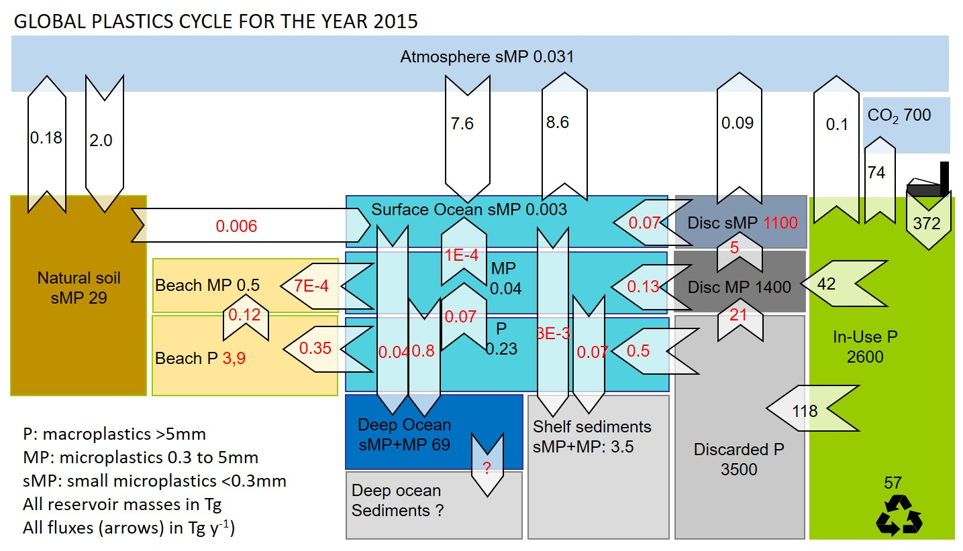

Figure 1. Global plastics budget for the year 2015. Reservoir sizes are shown in teragrams (Tg), and fluxes in Tg y-1 (arrows). Three plastics size classes are considered: macroplastics > 5mm (P), microplastics from 0.3 to 5mm (MP), and small microplastics <0.3mm (sMP) that can become airborne. The discarded plastic pools represent the terrestrial anthroposphere, including urban-industrial areas, landfills, agricultural soils impacted by mulching or waste disposal, and wetlands. The remote soil reservoir lies outside the anthroposphere and is only impacted by airborne sMP deposition, re-emission and runoff. Numbers in black are based on observations, and numbers in red on box model optimization.

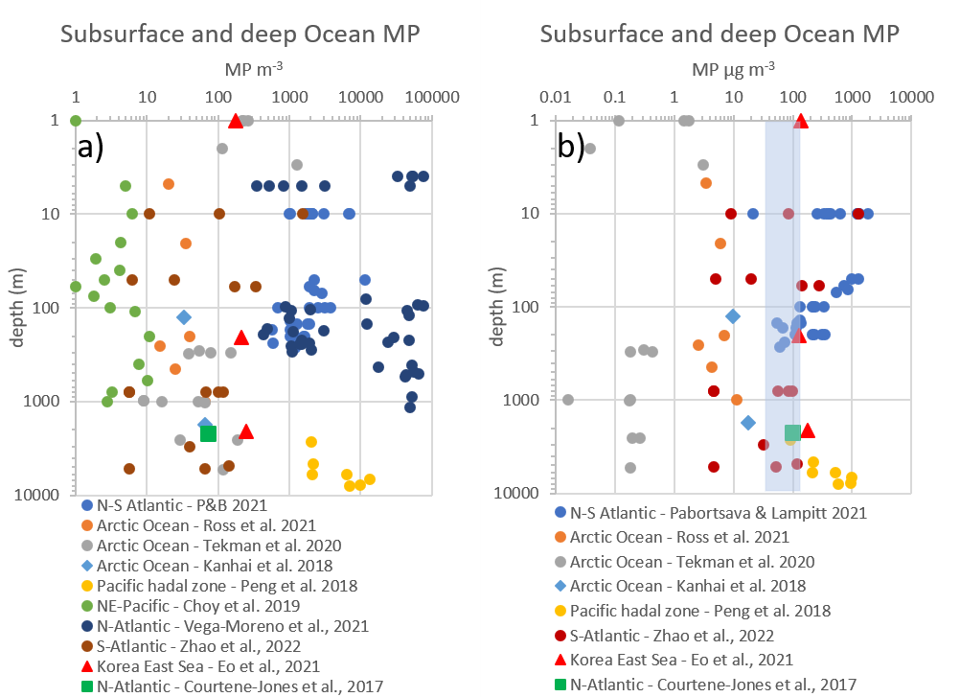

Figure 2. Marine subsurface microplastics observations. a) combined MP and sMP number concentrations per m3. b) MP and sMP mass concentrations for datasets where particles/fiber size distribution was reported (see Methods). The shaded vertical bar indicates the range of mean mass concentrations estimated for the Pacific and Atlantic Oceans.

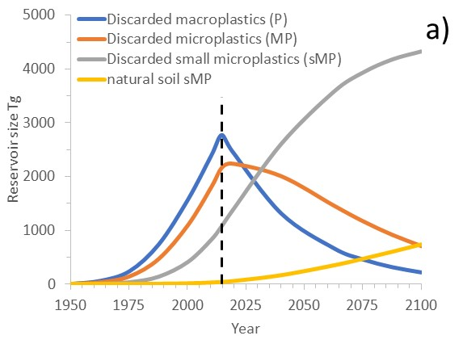

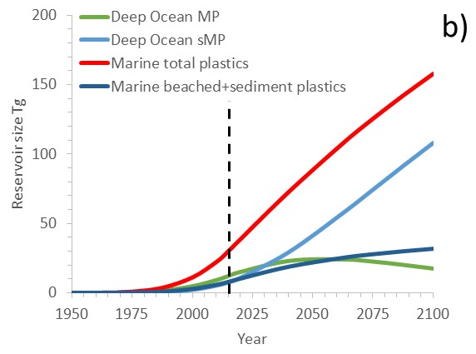

Figure 3. Box model results for plastics cycling through time. From 2050 to 2015 the model estimates the dispersal of P, MP and sMP in different Earth surface reservoirs, based on known plastics production and waste generation. From 2015 to 2100 the model illustrates plastics fragmentation and dispersal in the case of a full stop of non-biodegradeable plastics in 2015.

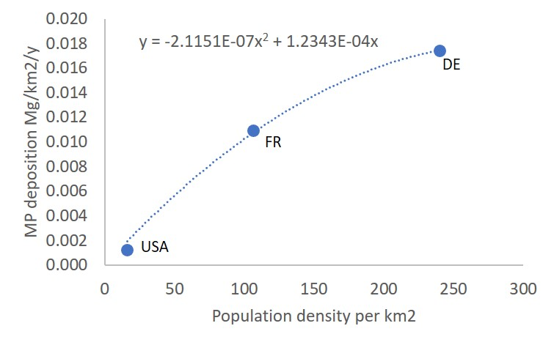

Figure S1. Atmospheric small microplastic deposition versus population density. sMP deposition to remote locations for the USA from (Brahney et al., 2020), for France (FR) from (Allen et al., 2019), and for urban location around Haburg, Germany (DE) from (Klein and Fischer, 2019).